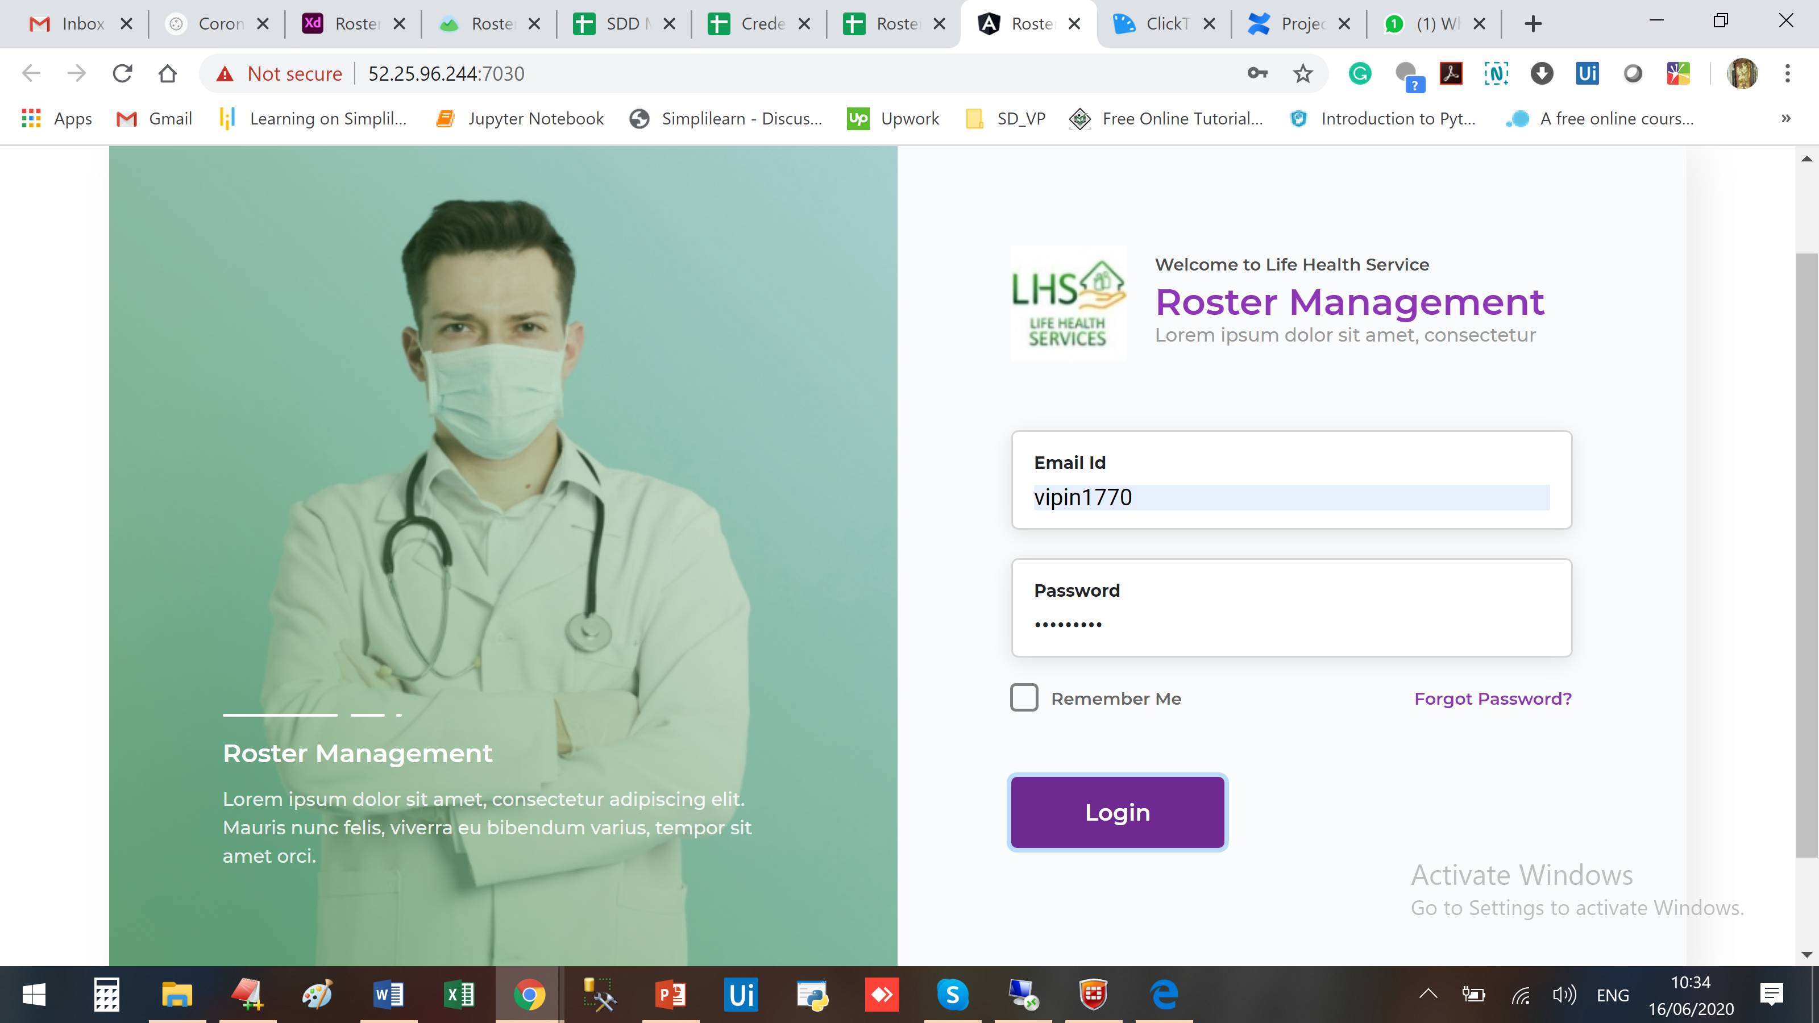

No action when trying with wrong password

Not able to Save Employee, not accepting DOB, Location should be drop down, having more observations also but as of now this is blocker.

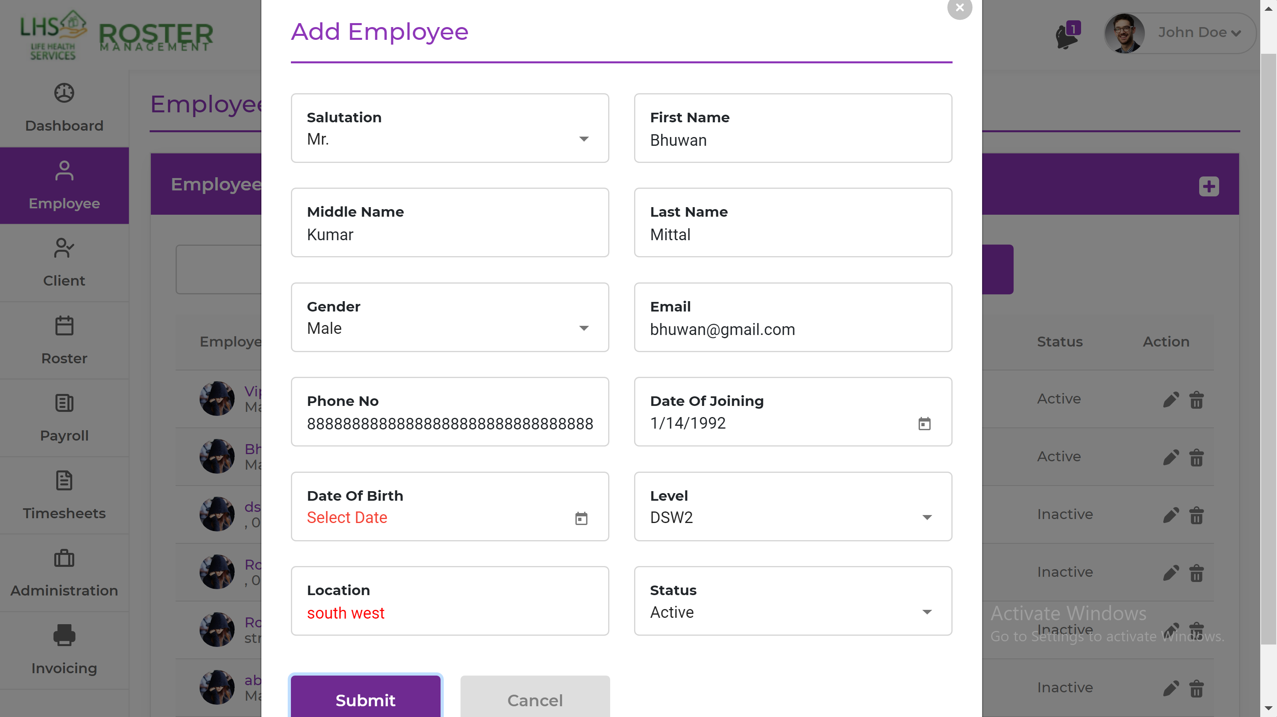

Look at the pop-up error when searching “bhuwan”

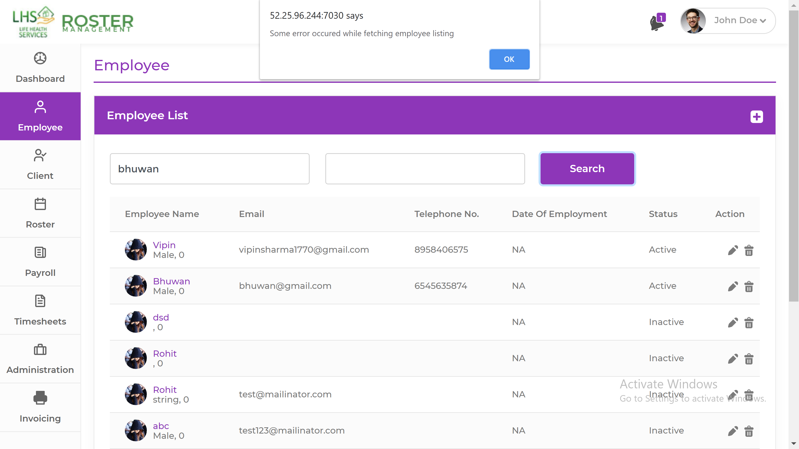

Look at the [Object Object] on top

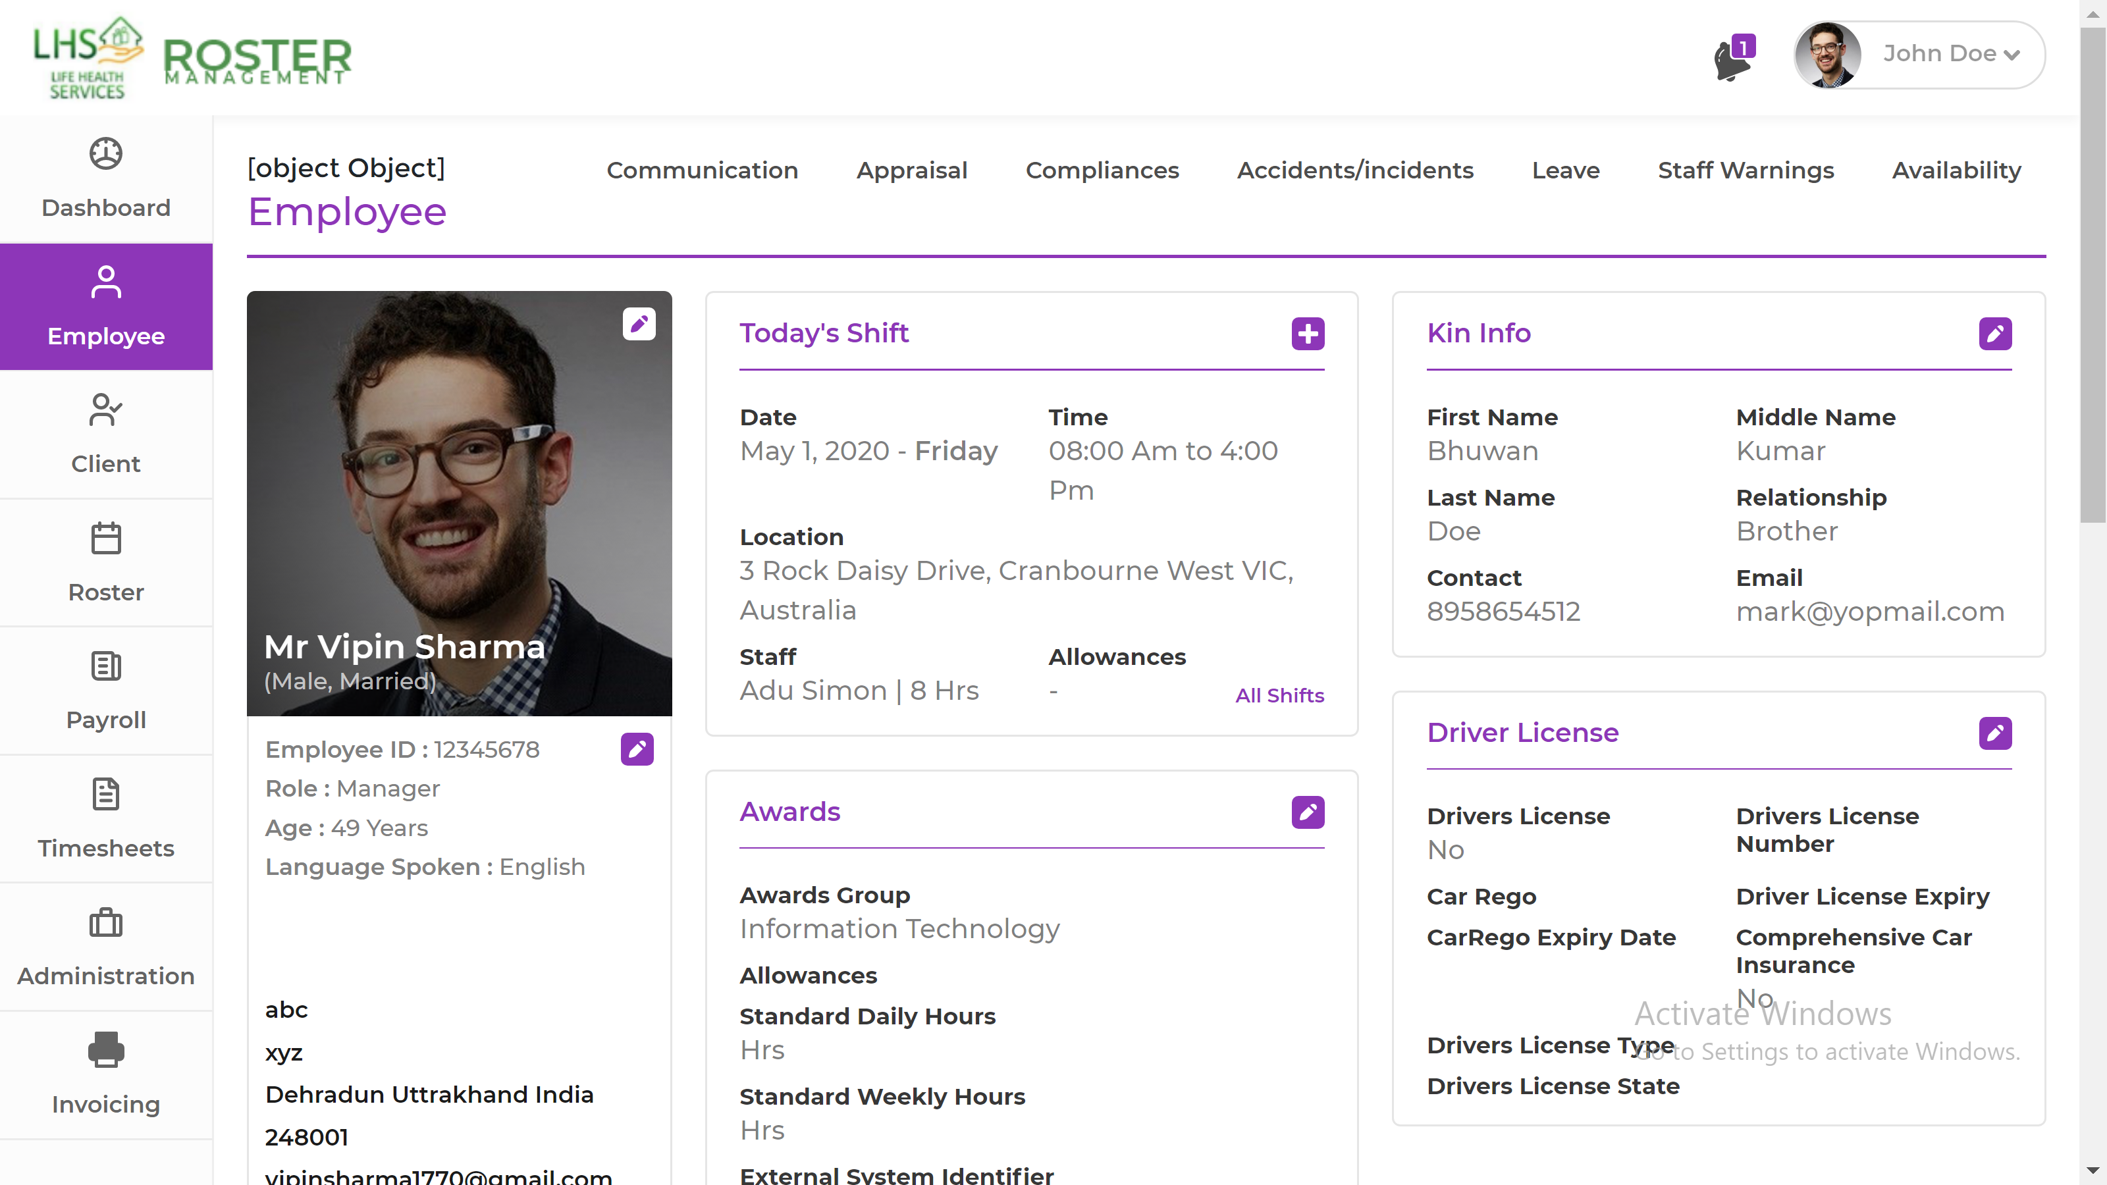

Data Repeating in Drop Down

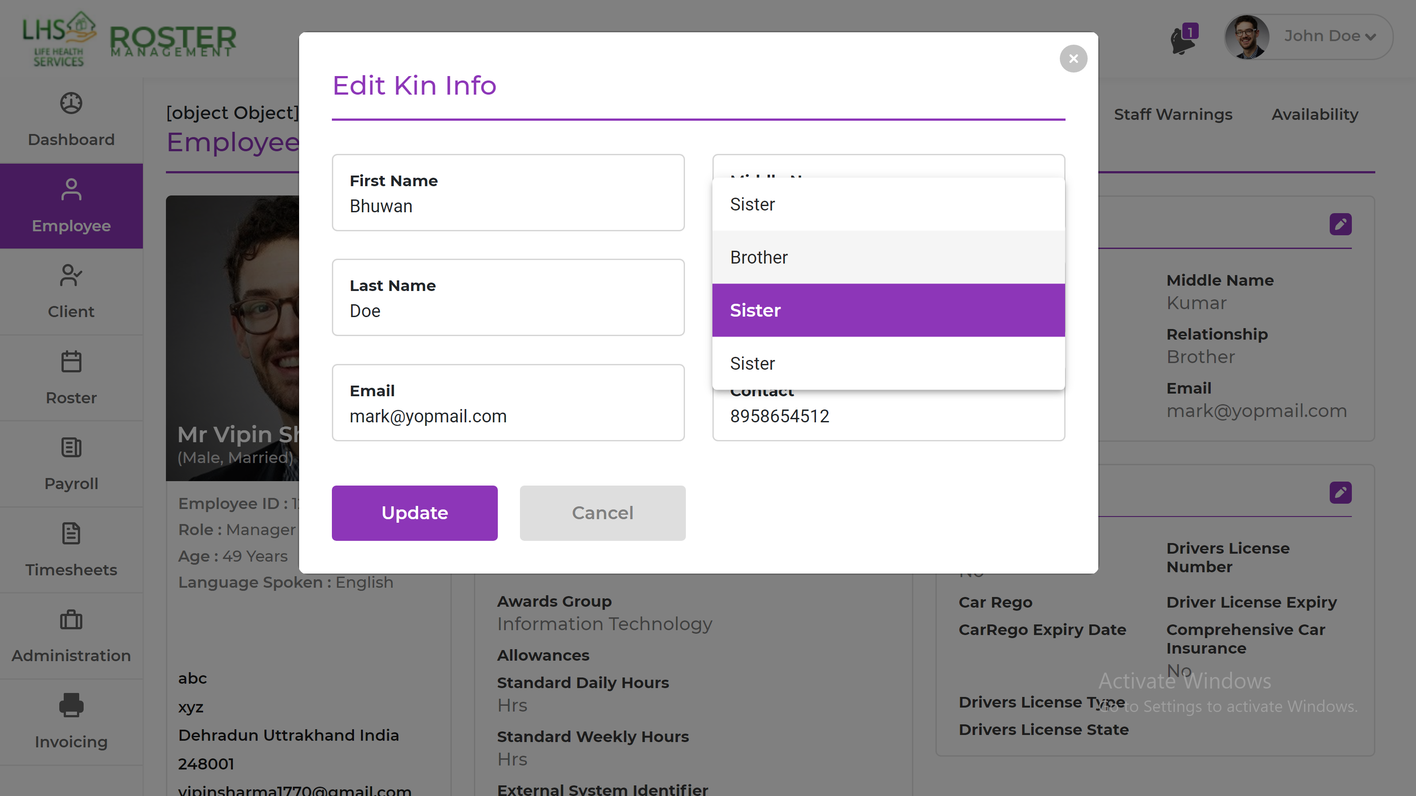

Update is not working

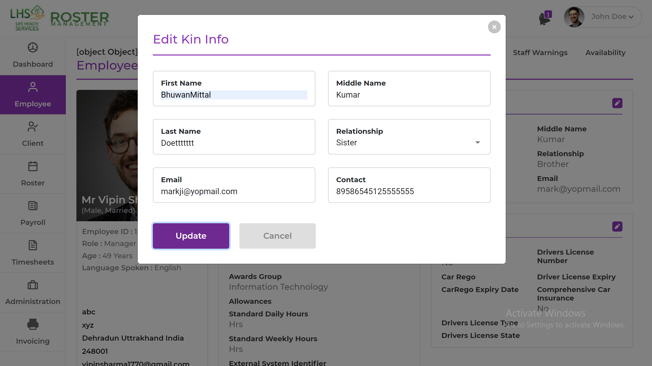

Look at the overlapping

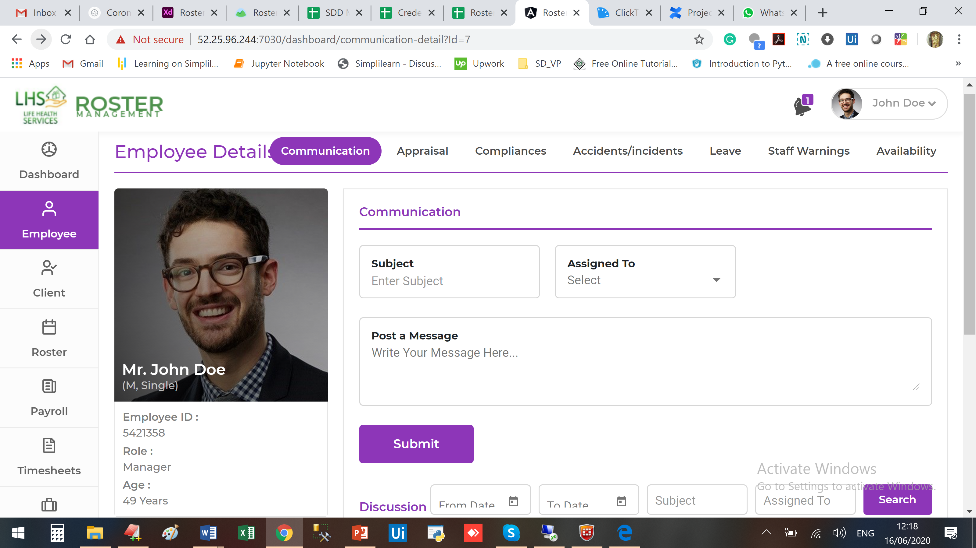

Edit is not working

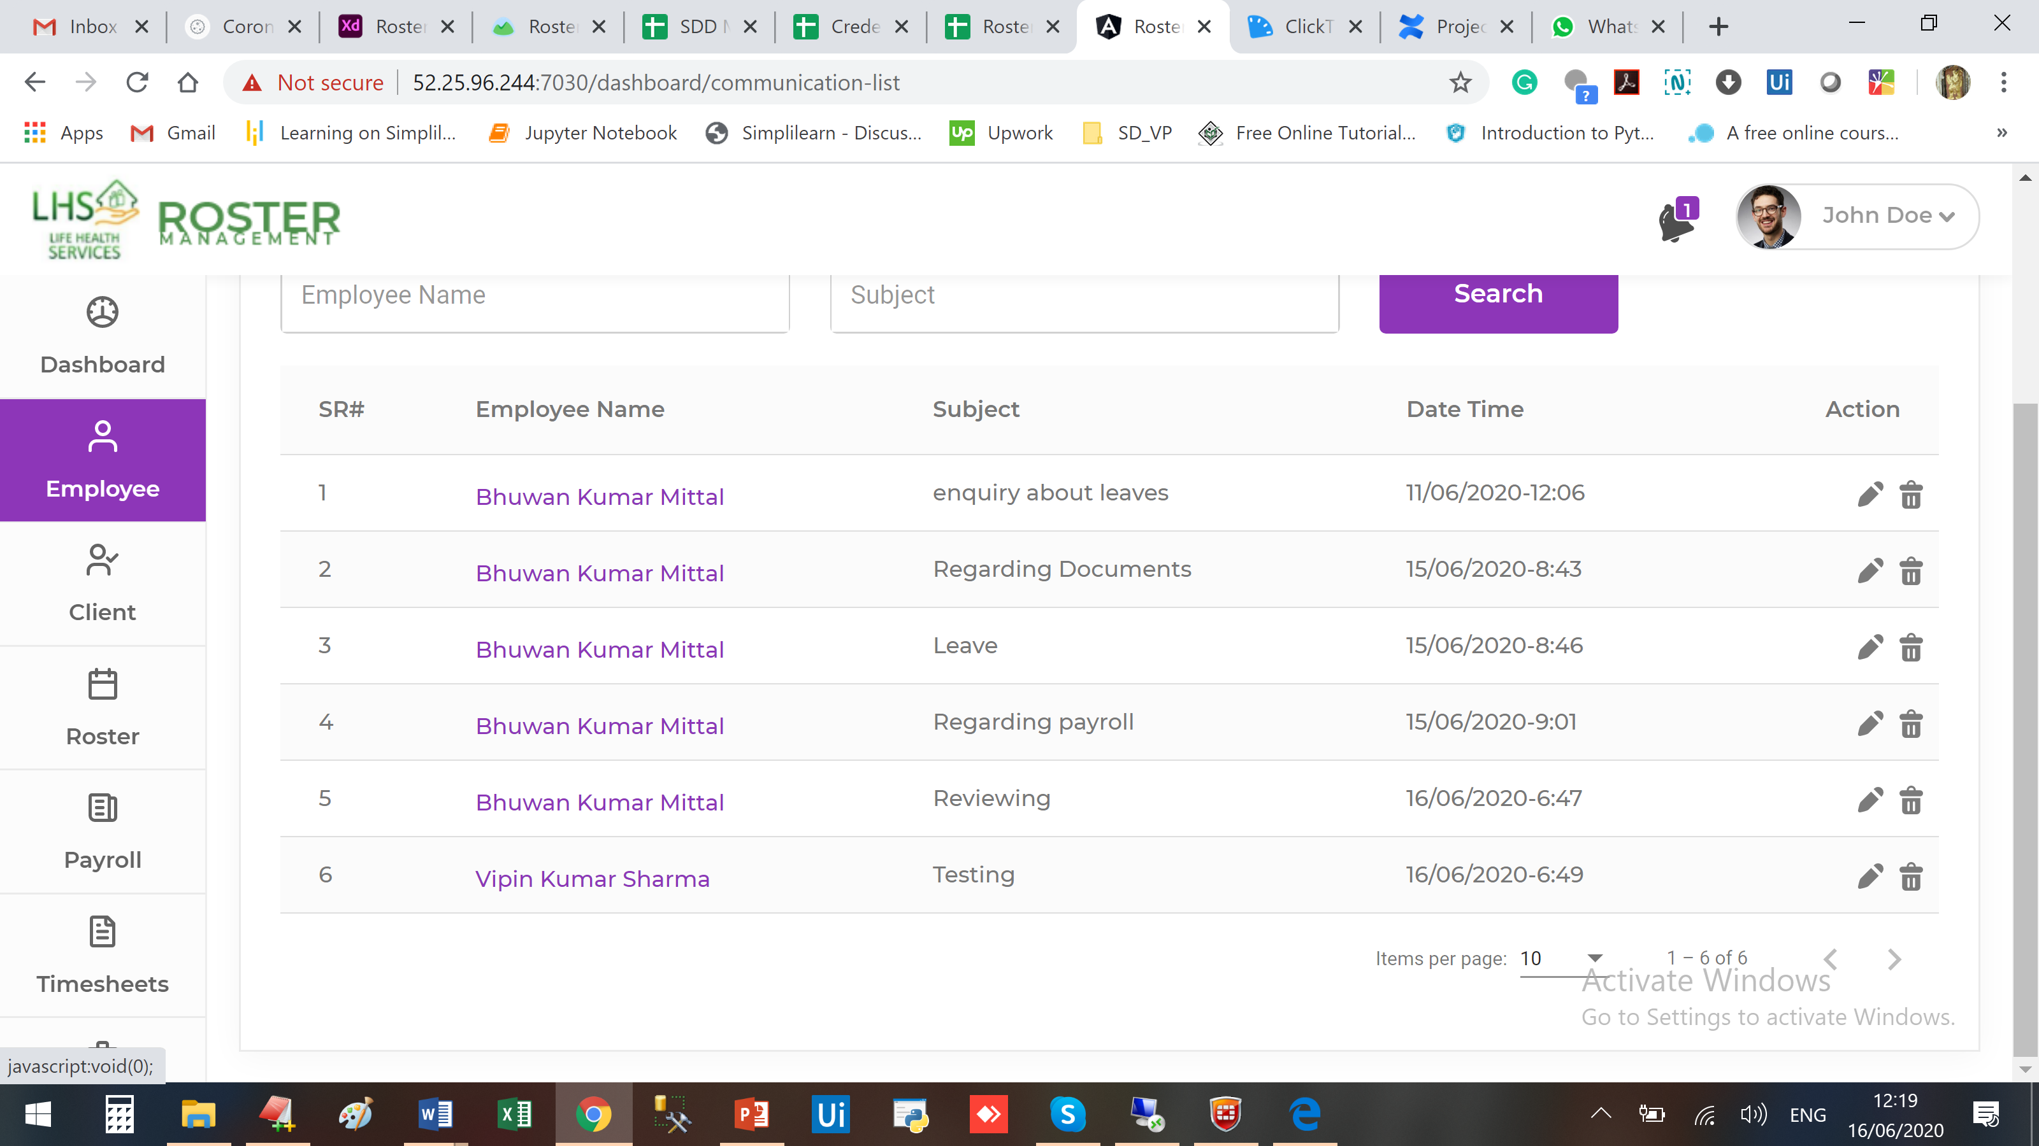

Employee List is not there in the Sub Menu

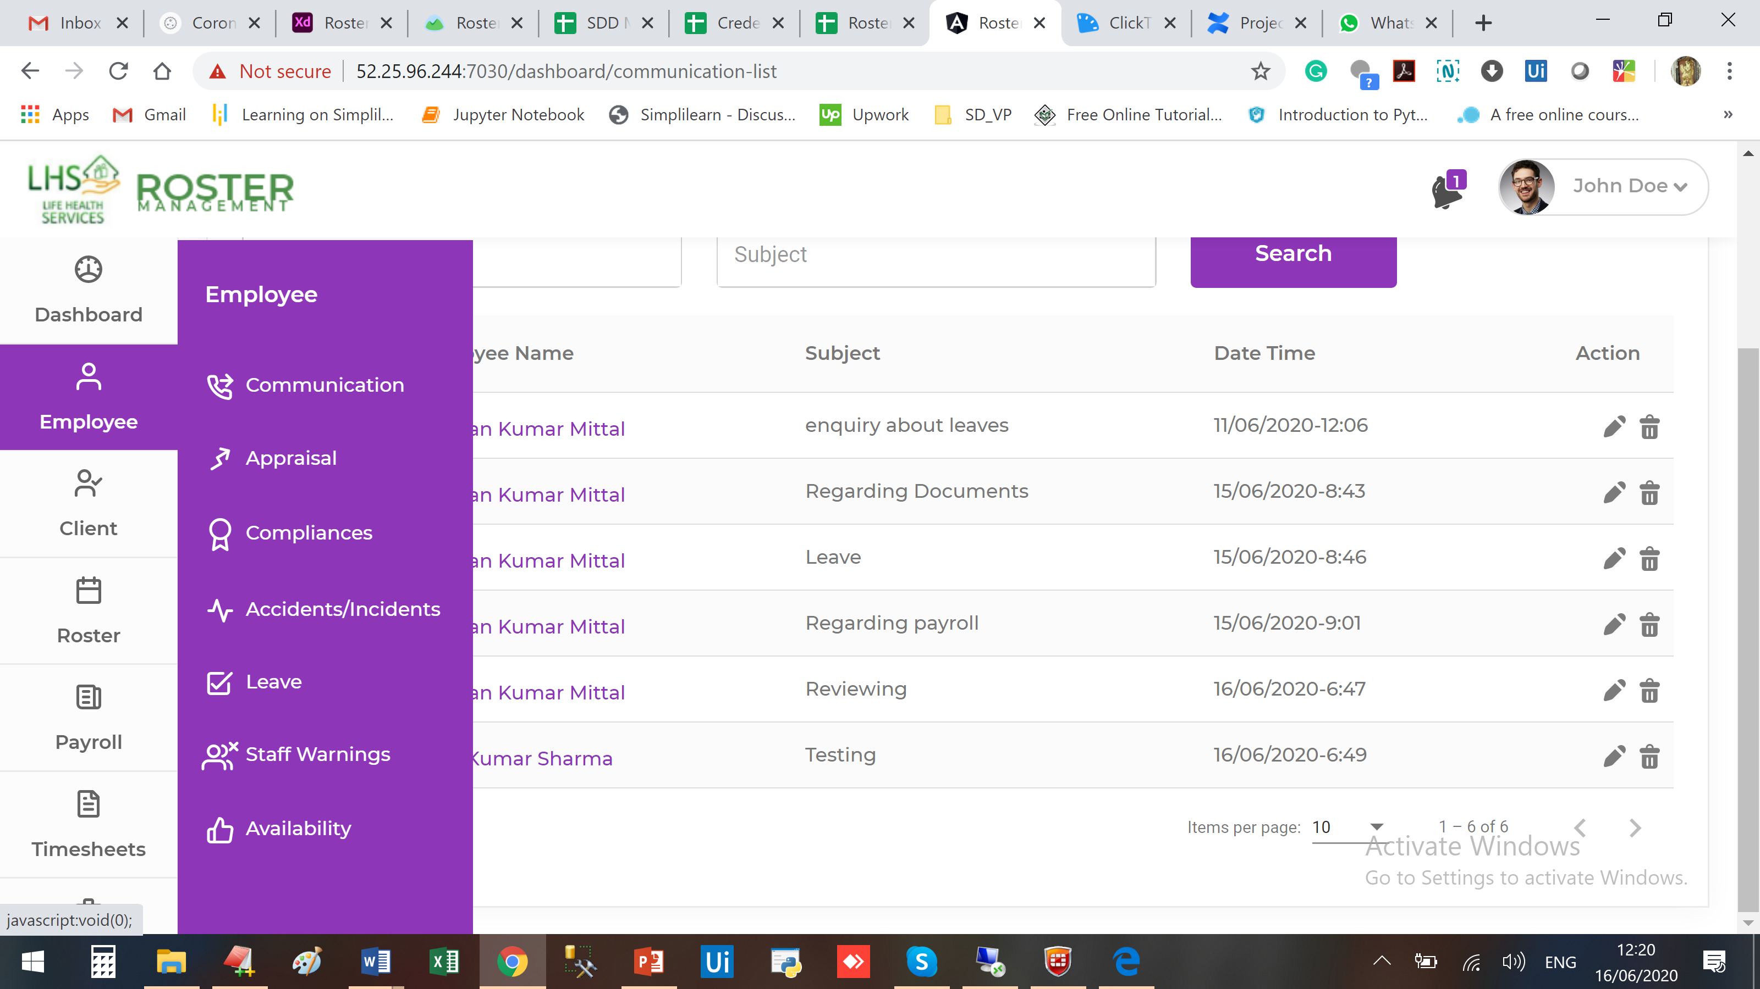

Look at the Grey section

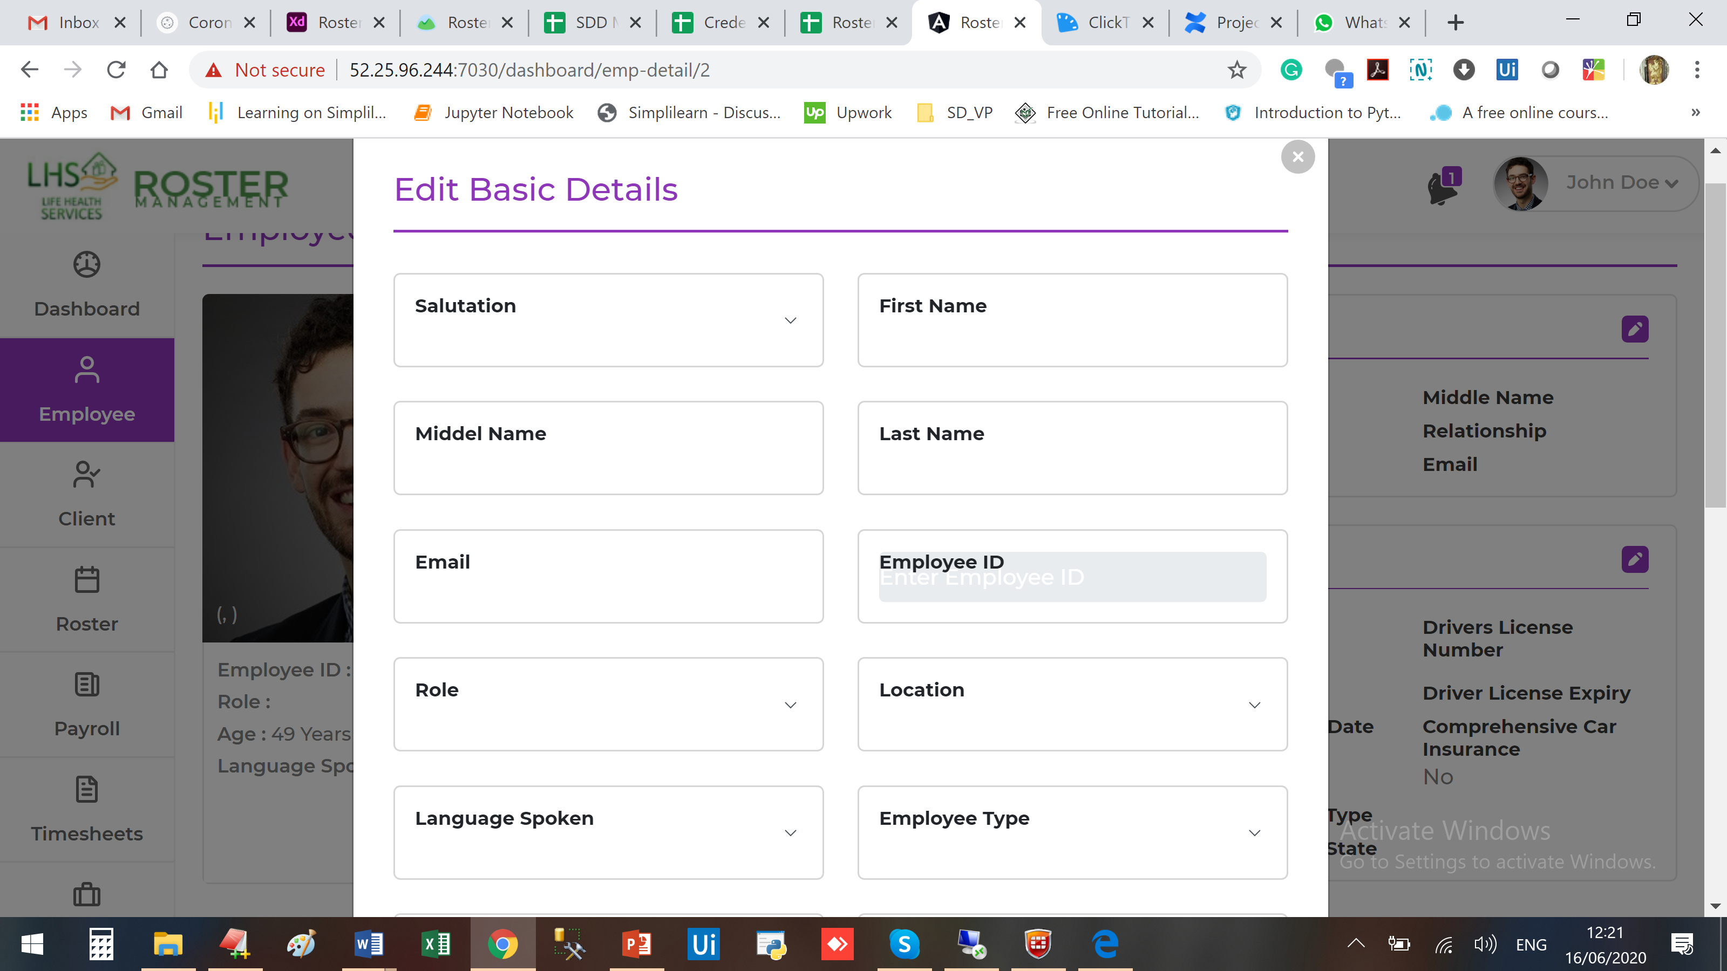

Look at the gap between heading and data entered

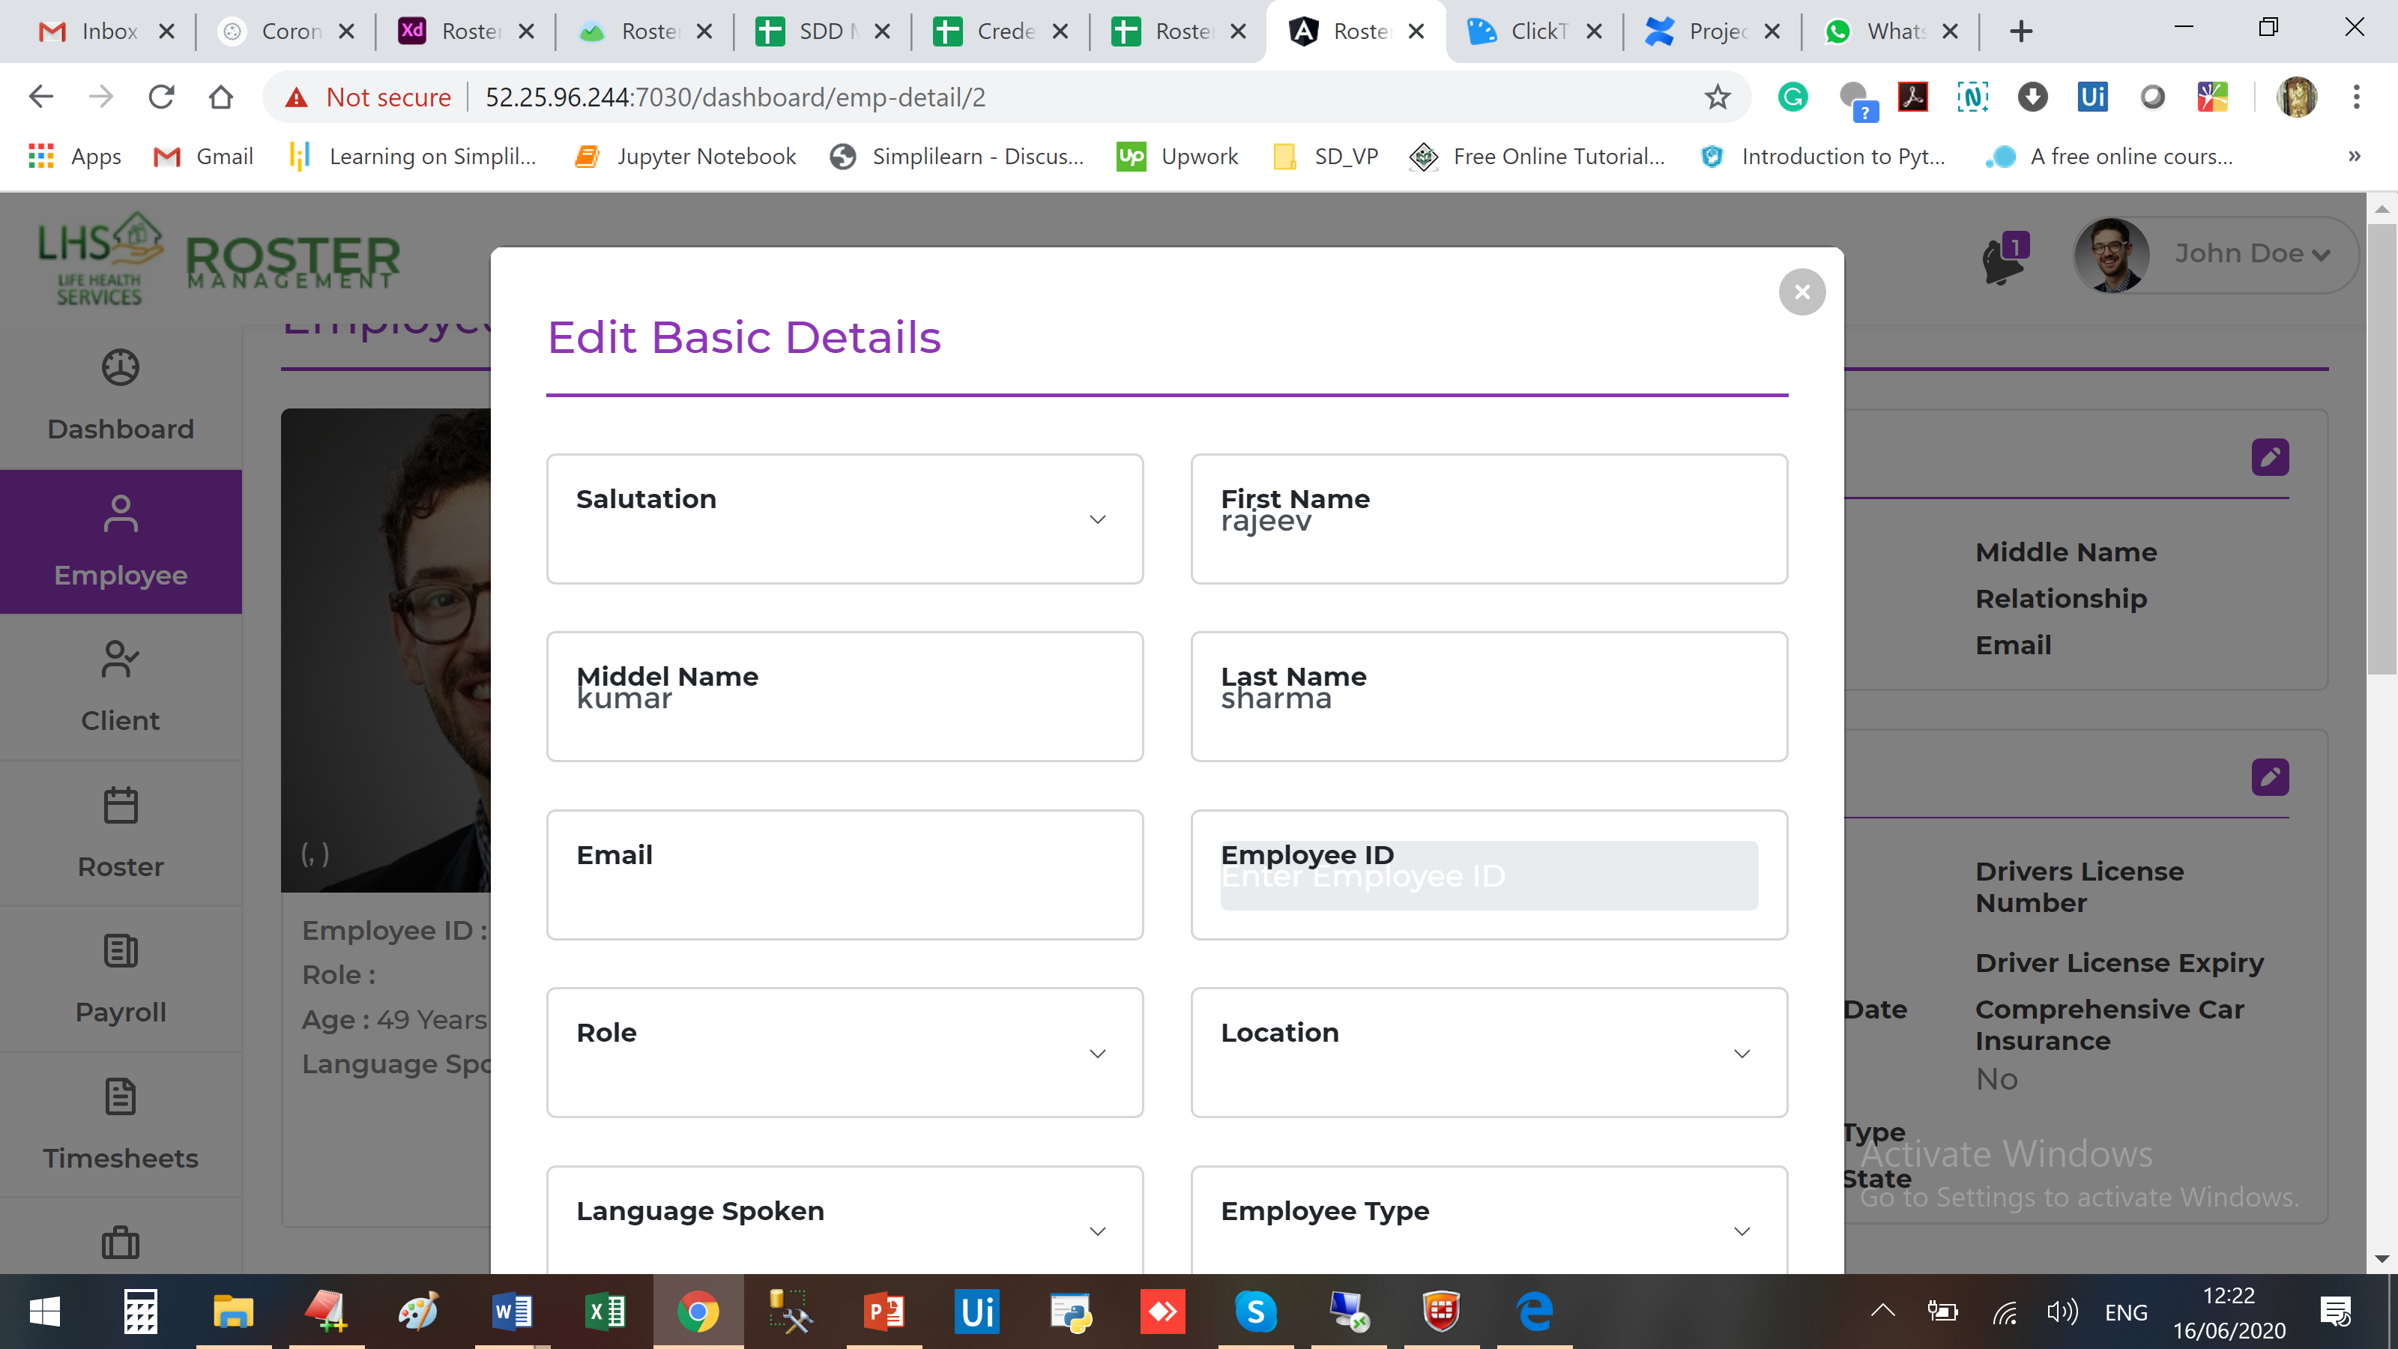

Back is not working on Employee Appraisal form
Submit is not working on Appraisal form

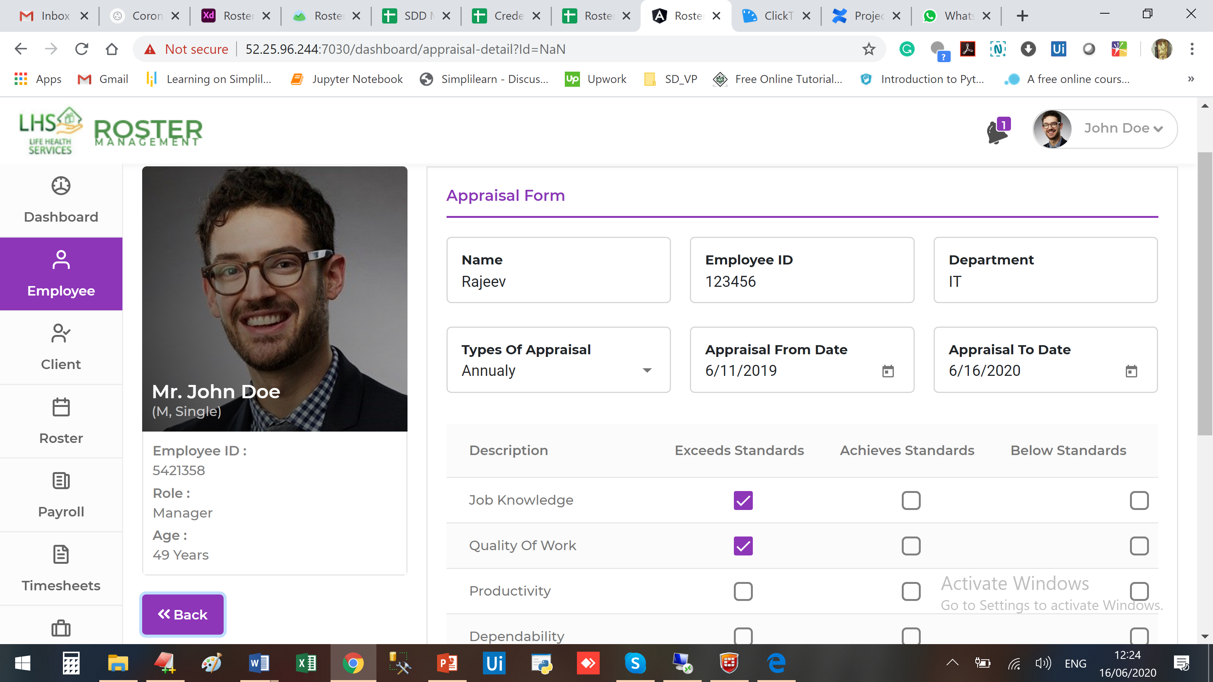

Several Validation issues (which can be taken care later)
Submit if not working on License page (this should be taken care)

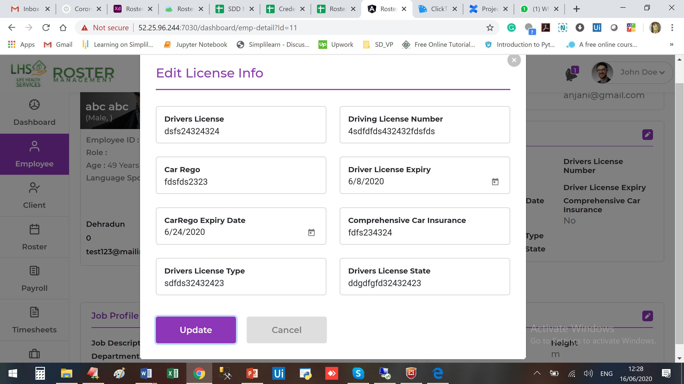

Data is not coming, its showing reference number from DB

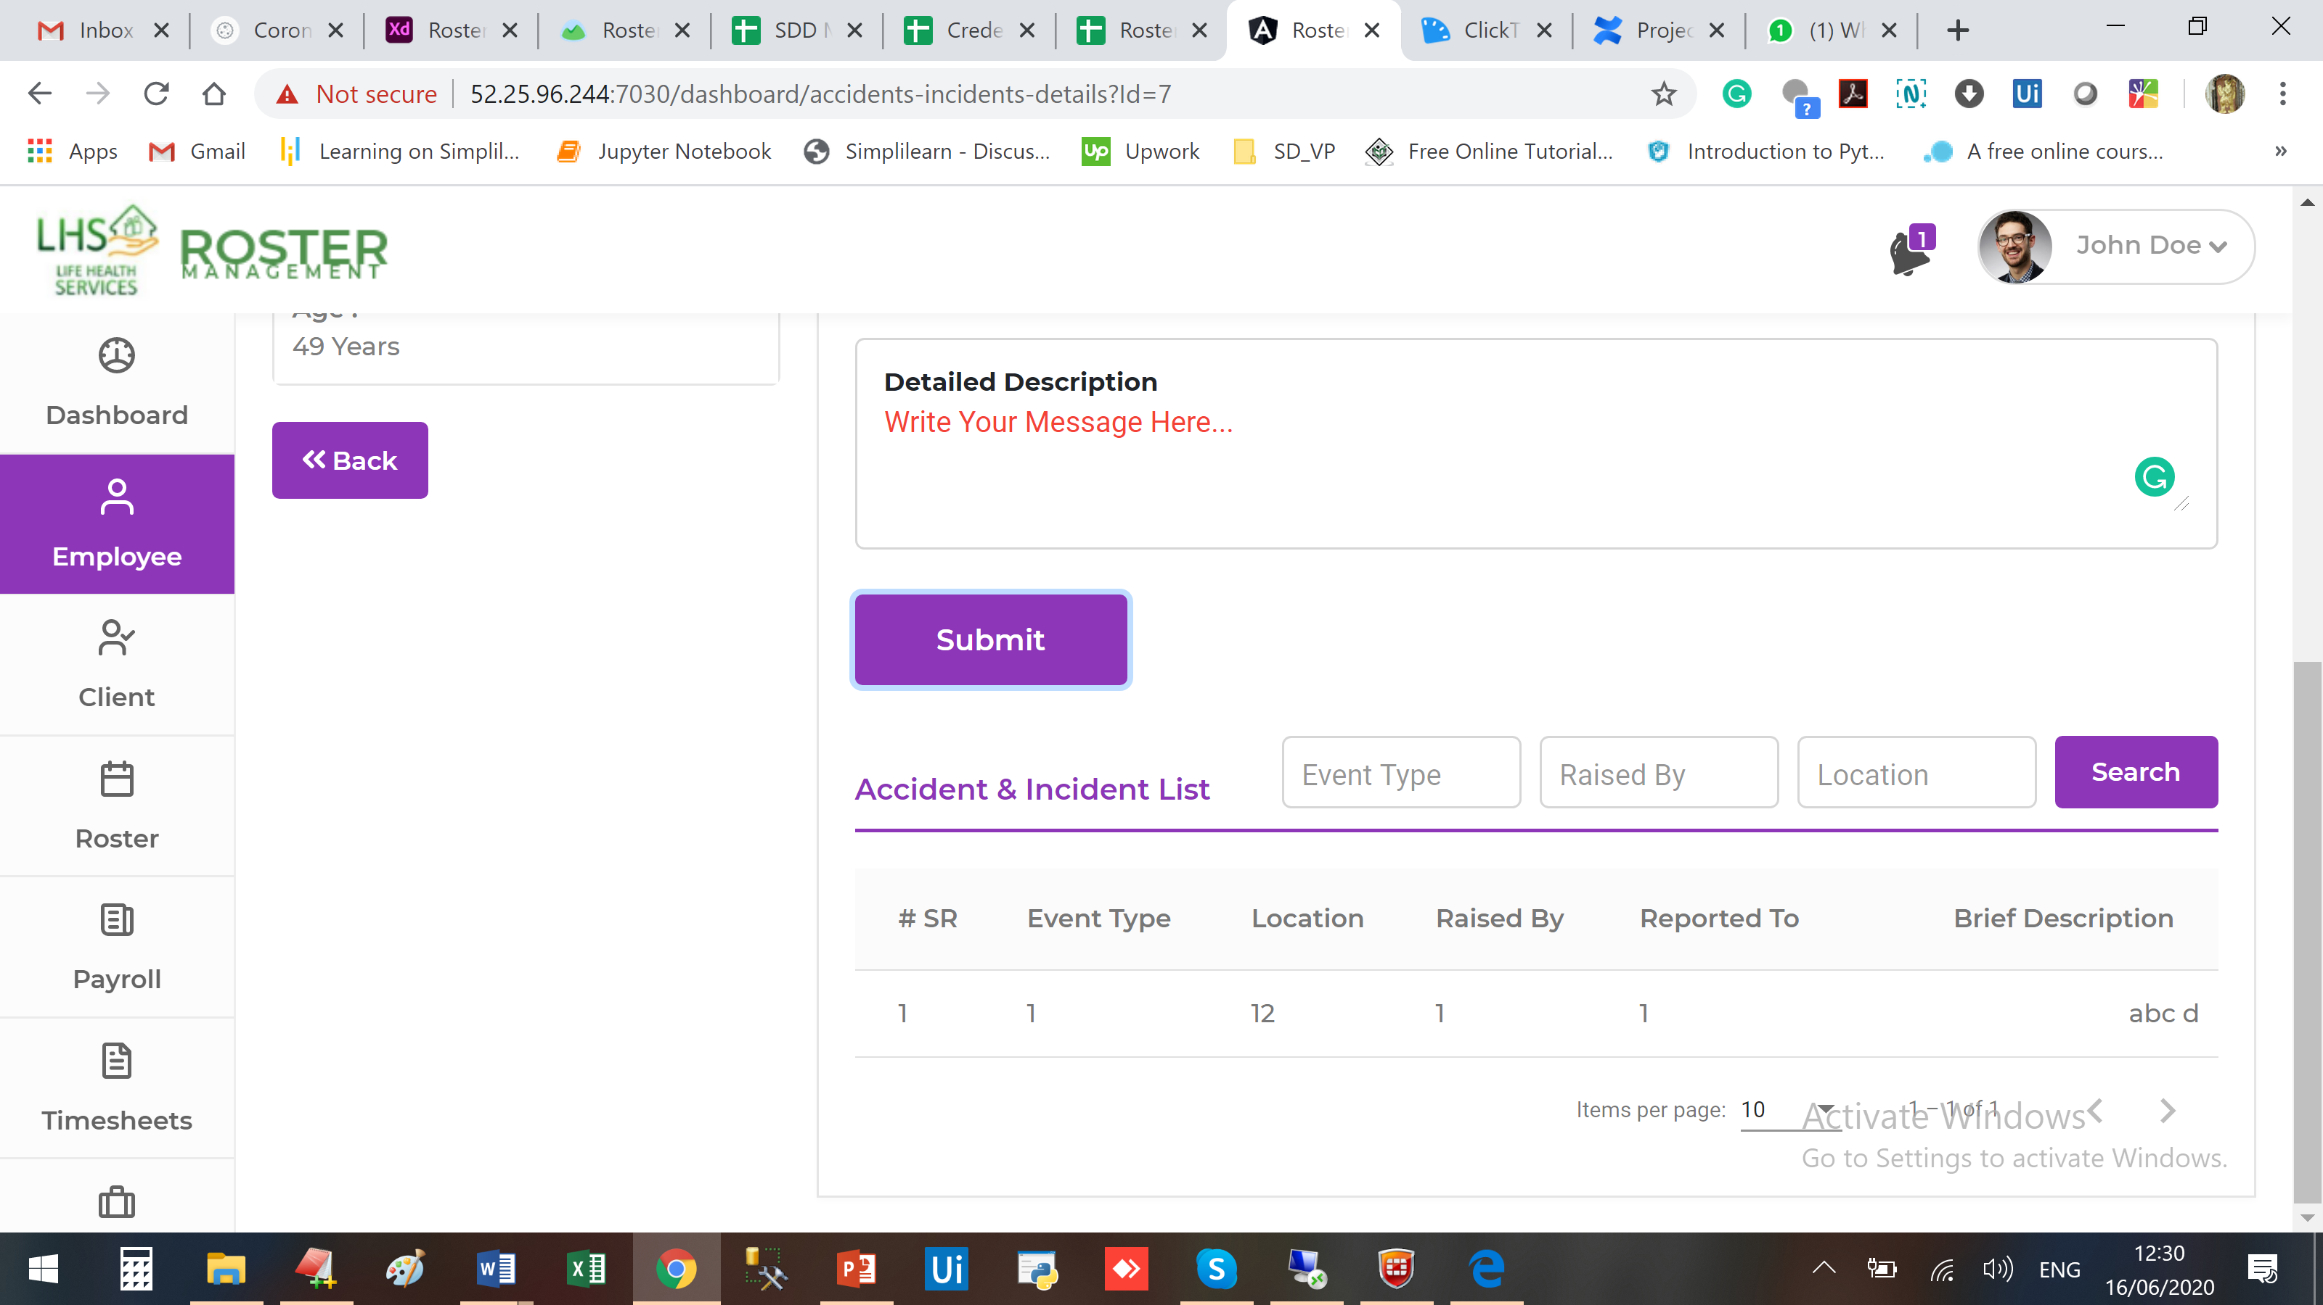

Accident/Incident Sub menu
Same here and Employee name is coming “Bhuwan” although I entered for ABC

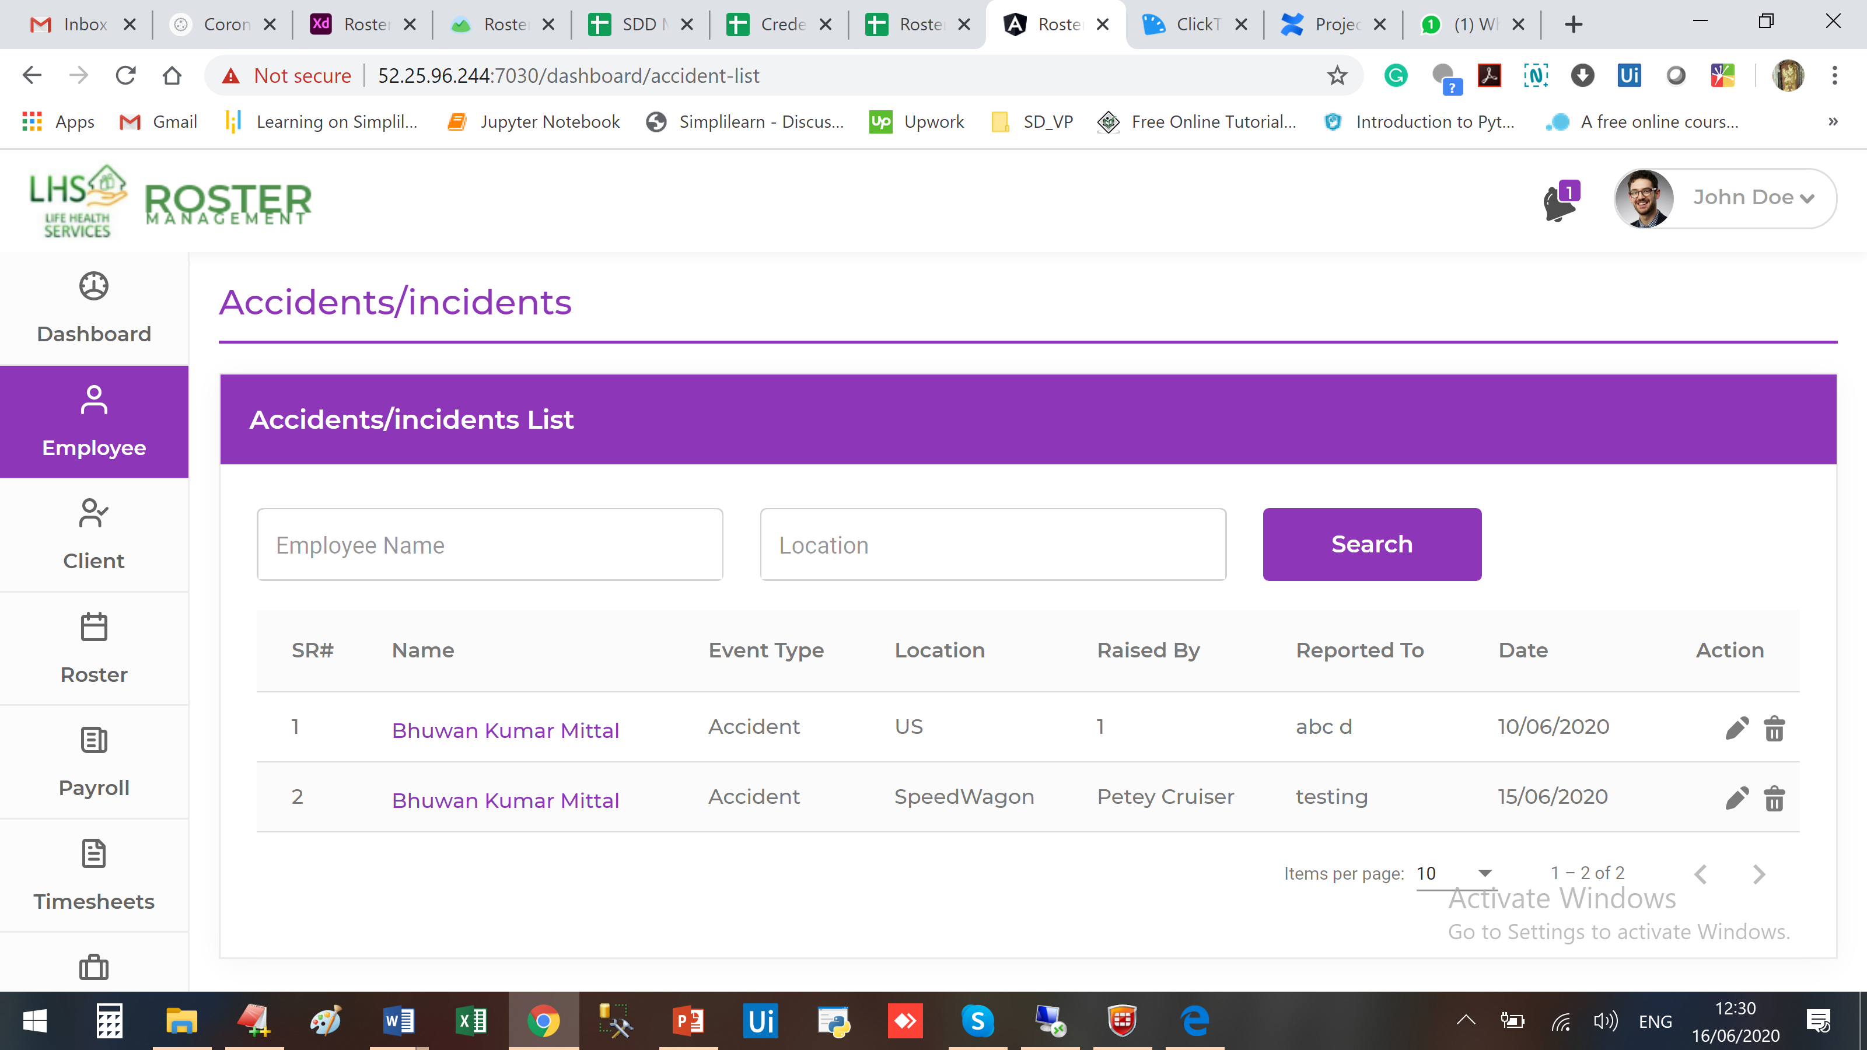

Look at the issue when refreshing the browser

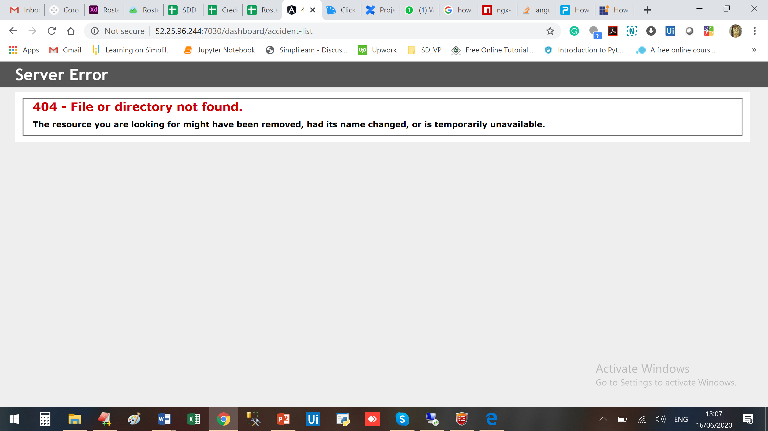

Not able to add leave

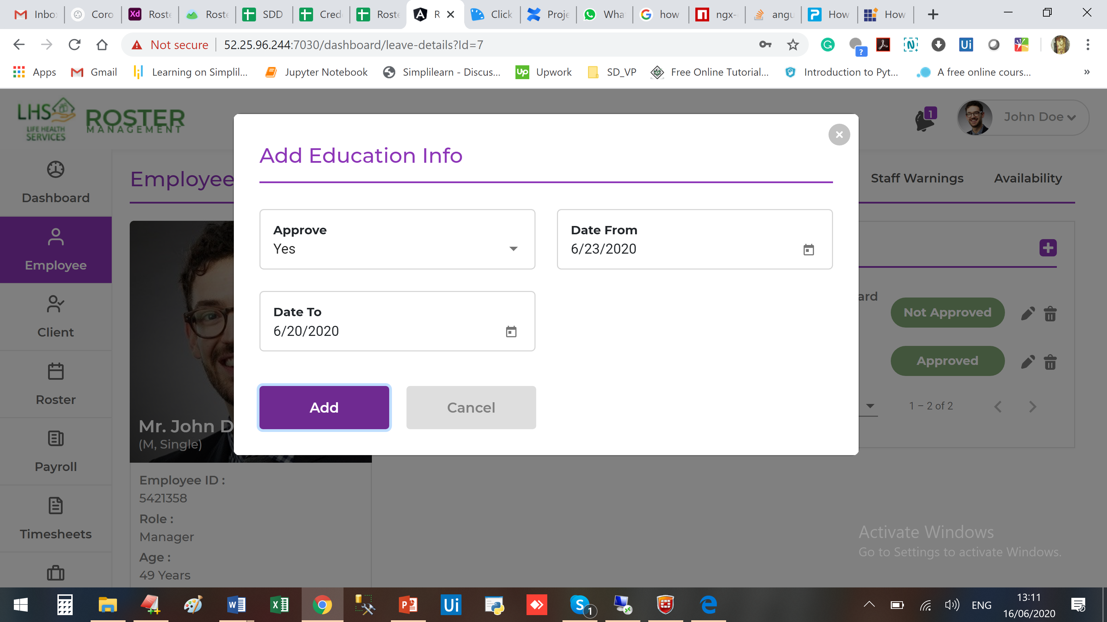

Not able to search anything on Leave (Sub Menu)

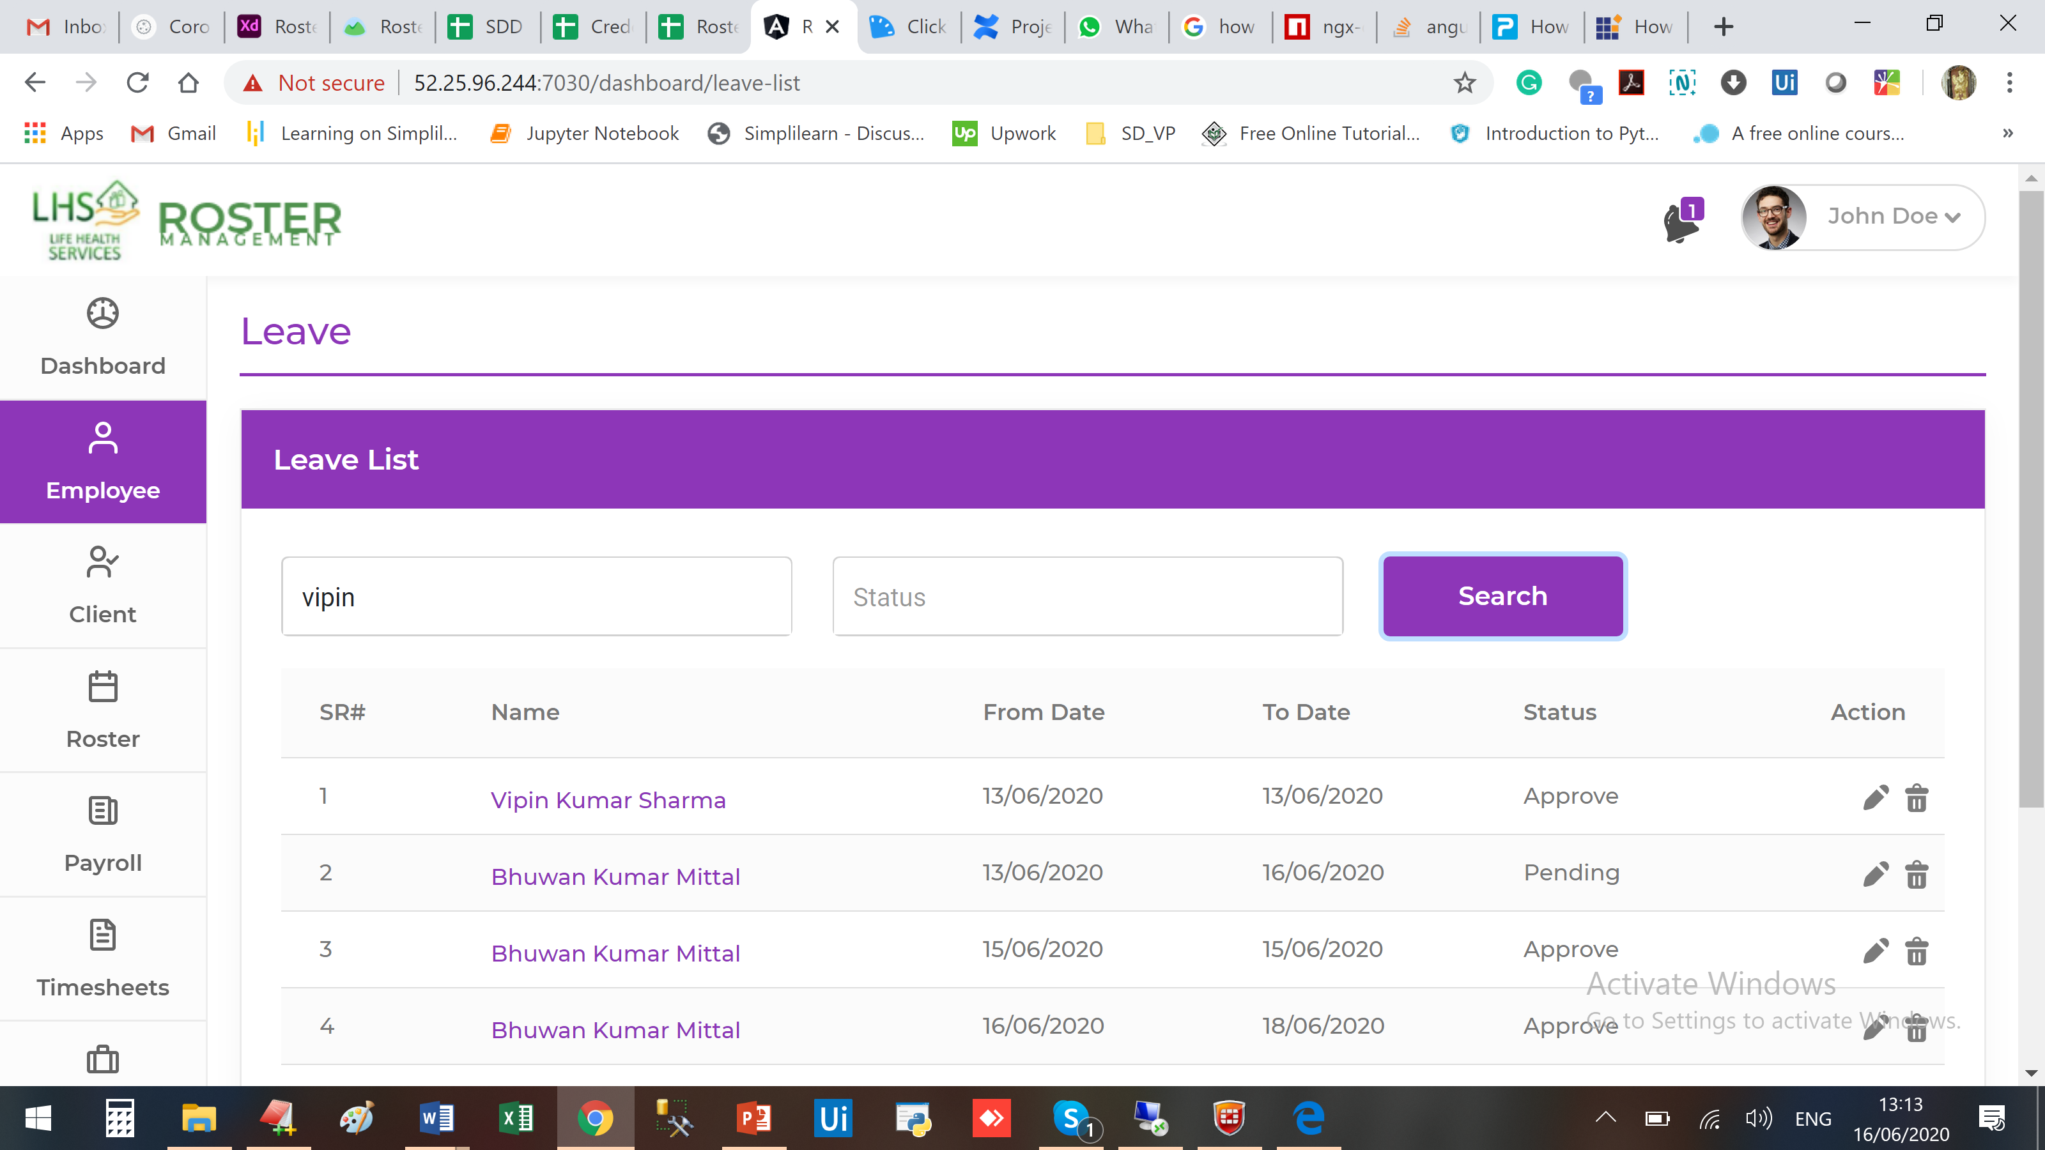

On Click on EDIT
- Don’t know editing for whom
- Dates are not correct, taking selected date – 1

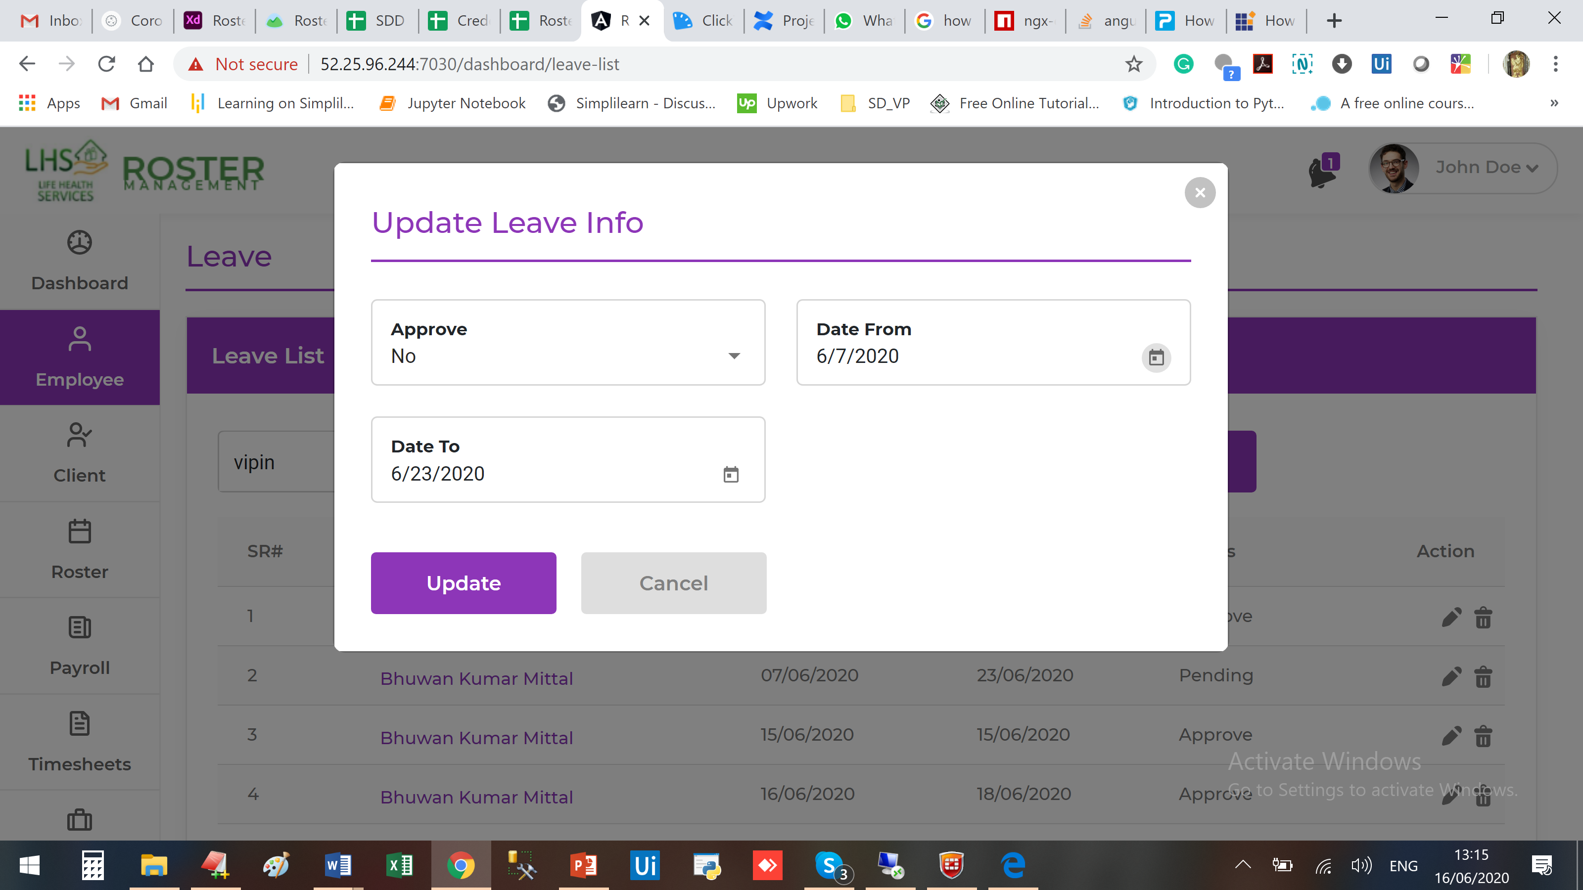

Employee data like Name/ID/Job Title/Reporting Manager/ should be auto populate because we are going from the inner page and we know the Employee data.

I guess this logic will be applicable in all the inner pages.

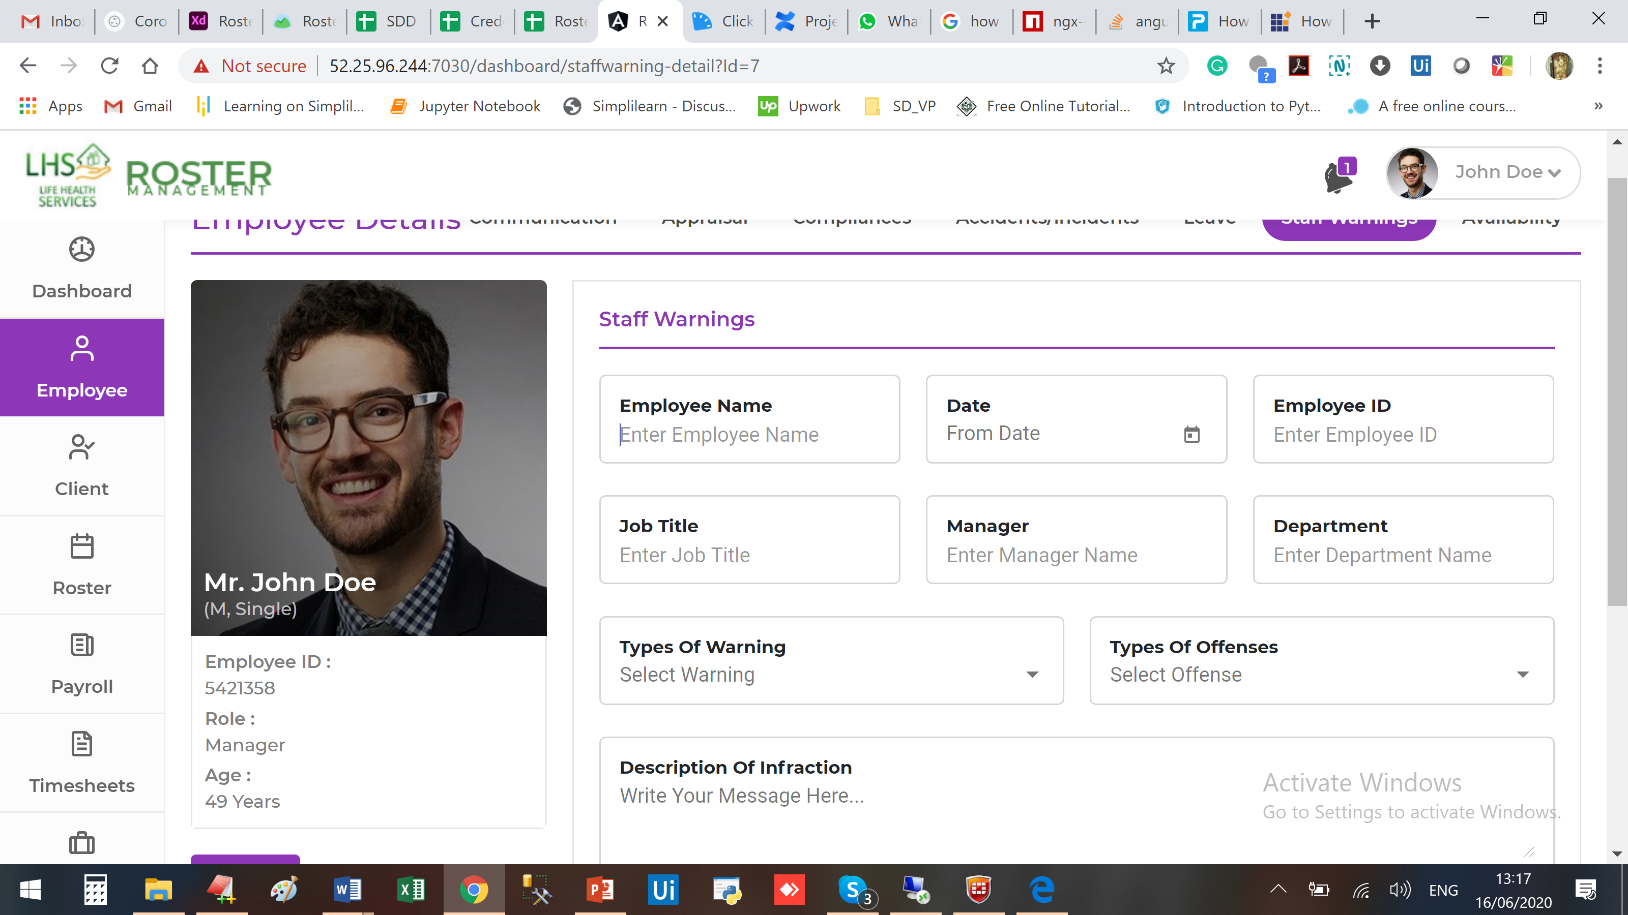

Not able to search anything here also

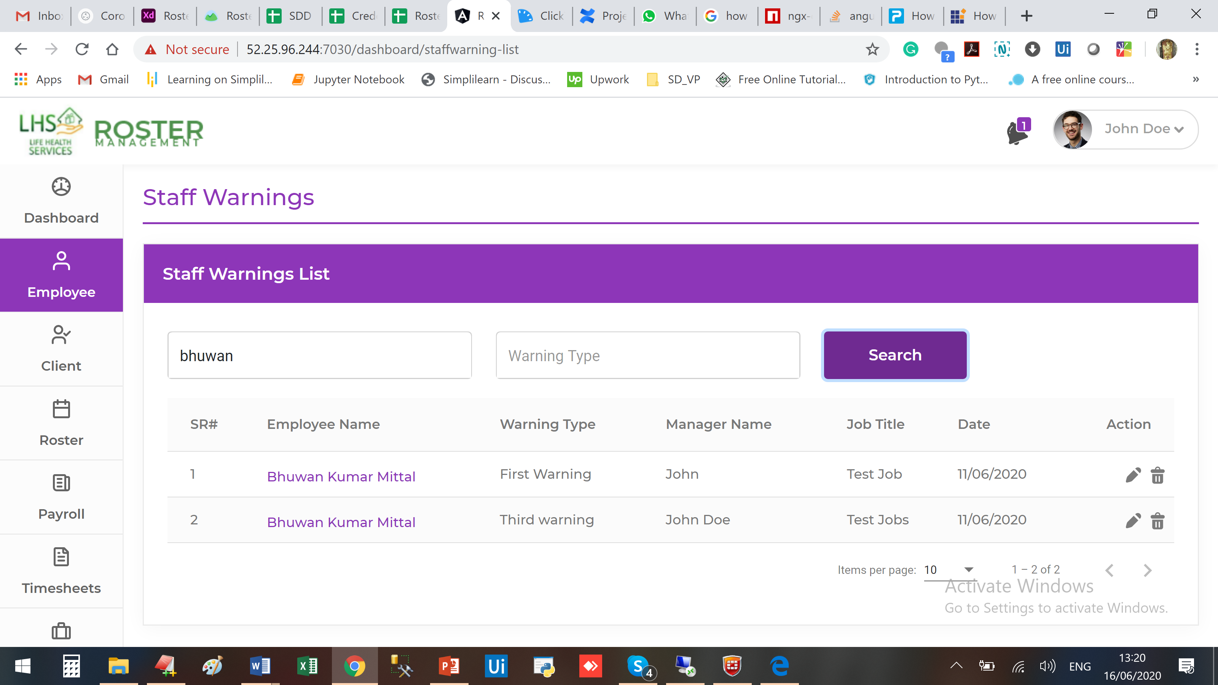

Edit is not working

